Task 1: SQL-Based Traffic Analysis
1.2 Analyse annual traffic trends
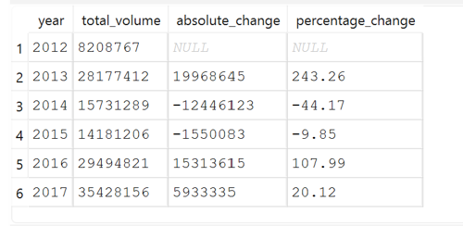
Meaningful Observations & Explanations
- As compared between year 2012 and 2017, it appears that there is a massive jump in traffic volumes in 2013 versus 2012 with the difference of 19,968,645 and in terms of %: a 243.26% increase which is very strange. If we dive in the dataset, for 2012, the dataset only start recording in October to December, hence giving us only a 3 months value as compared to a full year in 2013.
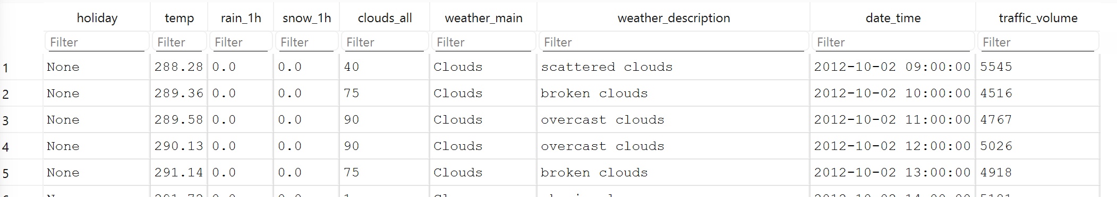

- In 2013, the volume is around 28 million, in 2016: 29 million and in 2017: 35 million. However in 2014 and 2015, the volume is only 15 and 14 million respectively which look very strange. If we dive in the dataset, it appears that the dataset for 2014 and 2015 is incomplete with 2014 recording until August period while 2015 start recording from June period.
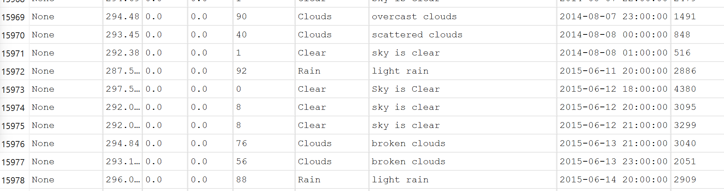

1.3 Analyse temperature around holidays

Year | Holiday | Average Temp (deg C) | Average Traffic Volume
2015 | Happy New Year | N.A. There is no datasets | N.A. There is no datasets
2016 | Happy New Year | -6.12 Deg C | 1815.0
2017 | Happy New Year | -3.06 Deg C | 2128.0
2015 | Labour Day | 21.87 Deg C | 973.0
2016 | Labour Day | 20.02 Deg C | 1064.0
2017 | Labour Day | 22.39 Deg C | 1026.0

For Happy New Year, the average temperature warm up by +3.06 deg C from year 2016 to 2017 and as a result, traffic volume surged substantially by +17.25%. If we look at the actual temperature from -6.12 deg C to -3.06 deg C, it gives human a significant feeling of temperature change from a colder sub-zero environment to a mild winter freeze hence ‘motivating’ them to move around so the traffic relevance is high.
For Labour Day, from year 2015 to 2016, the average temperature dropped by -1.85 deg C and traffic volume grew by +9.35%. For year 2016 to 2017, the average temperature increase by +2.37 deg C and traffic volume decrease by -3.57%. As the temperature hover between 20.02 Deg C to 22.39 Dec C from year 2015 to 2017 which does not give human a feeling of a significant temperature change, so most likely the traffic relevance is low and the slight shifts in traffic volume are likely driven by other factors.

Task 2: Descriptive Statistics and Correlation
2.1 Traffic volume statistics

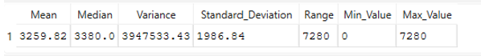

- Central Tendency & Bimodal Traffic Flow:
The Median (3,380.0) sits slightly higher than the Mean (3,259.82). In normal descriptive statistics, this hints at a slight negative skew. However, given that this tracks interstate commuter traffic, this relationship points to a strong bimodal distribution. The highway operates primarily in two extreme phases: packed, high-volume day-time rush hours and nearly empty, low-volume late-night hours. The mean and median sit directly in the valley between these two major daily states.
- Extreme Daily Volatility:
The Standard Deviation (1,986.84) is exceptionally large—representing over 60% of the mean value. This tells you that hourly traffic numbers on this interstate do not hover stably around the average. Instead, at any random hour, the vehicle volume is expected to swing drastically by roughly ±2,000 vehicles, demonstrating extreme volatility governed primarily by time-of-day variables.
- Structural Throughput Saturation:
The physical Range (7,280) bounds the absolute operating capacity of this stretch of westbound I-94. The minimum value of 0 indicates total standstills, overnight construction closures, or brief sensor dropouts. The maximum value of 7,280 marks the absolute empirical ceiling—the point where the highway lanes hit complete saturation under peak rush hour flow.

2.2 Correlation analysis
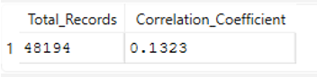
Interpretation of the Relationship
1. Direction of the Relationship
The correlation coefficient is positive (\(r > 0\)). This means that as temperatures increase, traffic volume generally tends to increase as well. Conversely, as temperatures drop (colder winter conditions), traffic volume shows a slight tendency to contract.
2. Strength of the Relationship
The relationship is very weak. In statistics, a correlation value between \(0.10\) and \(0.29\) is classified as a minor or weak positive association. Even though temperature has a mathematically positive track, the value is so close to \(0\) that it proves temperature is not a dominant predictor of hourly traffic volume on a day-to-day basis.

Why Correlation Does Not Imply Causation
A common trap in data analytics is assuming that because two variables move together, one causes the other. A correlation coefficient only measures mathematical alignment, not a cause-and-effect relationship, for several key reasons:
- The Presence of Confounding Variables (Third-Variable Problem):
Traffic volume is strongly dictated by the hour of the day and human schedules (e.g., morning and afternoon rush hours). Coincidentally, temperatures naturally peak during the afternoon because of solar cycles—exactly when afternoon rush hour occurs. The sun warming the air does not cause people to drive; rather, standard business operating hours drive both human transit and afternoon heating simultaneously.
- Coincidence and Spurious Associations:
Over a massive dataset (nearly 48,000 rows), minor random alignments can create a statistically significant, non-zero correlation coefficient even when no actual physical mechanism links the hourly variations directly.
- Missing Contextual Nuance:
Temperature variations are highly seasonal. A driver might maintain their daily routine whether it is \(15^{\circ }\text{C}\) or \(25^{\circ }\text{C}\) in the summer. Extreme drops (like freezing blizzards) definitely deter travel, but the subtle day-to-day temperature movements captured by this weak \(0.1302\) coefficient reflect minor background fluctuations rather than a direct causative impact.

Task 3: Probability and Congestion Analysis

Interpretations & Discussion
1. Statistical Independence Test
- Formula Check: \(P(\text{Congestion} \cap \text{Clear Weather}) = 0.0366\), while \(P(\text{Congestion}) \times P(\text{Clear Weather}) = 0.0409\).
- Conclusion: Because \(0.0366 \neq 0.0409\), weather conditions and congestion cannot be considered strictly independent.
- Direction: The joint probability (\(0.0366\)) is slightly lower than what we would expect if they were purely independent (\(0.0409\)). This tells us that congestion and perfectly clear skies occur together less often than random chance would dictate.
2. Odds Ratio Interpretation
- Your Value: 0.736
- Interpretation: Because the odds ratio is less than 1.0, the odds of experiencing traffic congestion are lower in clear weather than in cloudy weather. Specifically, the odds of hitting a traffic jam when the weather is clear are about 26.4% lower (\(1 - 0.736\)) compared to when the sky is covered in clouds.

Summary of Weather vs. Congestion Relationship
Your probability analysis suggests a clear, measurable link between atmospheric conditions and traffic flow:
- Weather Acts as a Commuter Buffer: When the weather turns clear, the probability of encountering clear skies given that you are already stuck in traffic drops to 24.83% (which is notably lower than the general occurrence of clear weather at 27.76%).
- Cloudy Conditions Aggregate Risk: The odds ratio of 0.736 indicates that cloudy weather actively correlates with a higher likelihood of heavy traffic congestion. This suggests that cloudy conditions (which are frequently tied to reduced natural light, lower temperatures, or incoming weather changes) prompt drivers to slow down or choose road travel over alternative transit modes, directly increasing the probability of hitting a breakdown or traffic bottleneck.

Task 4: Power BI Traffic Intelligence Dashboard
4.2 Dashboard analysis
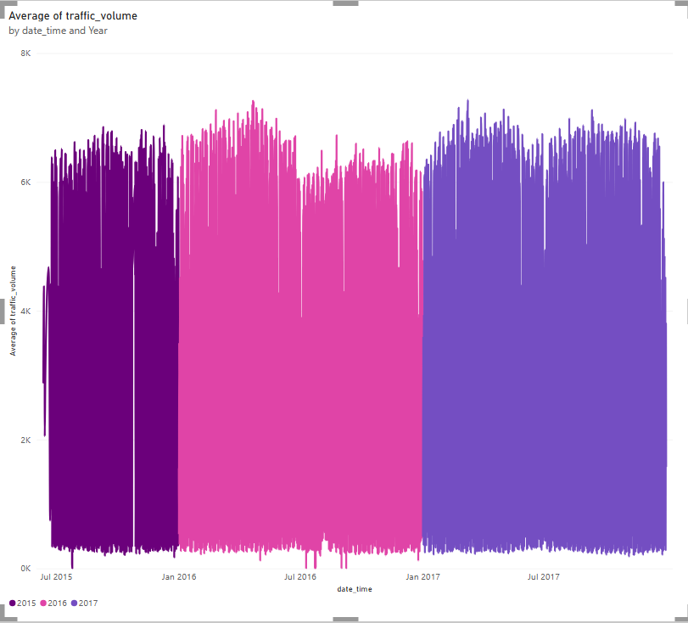
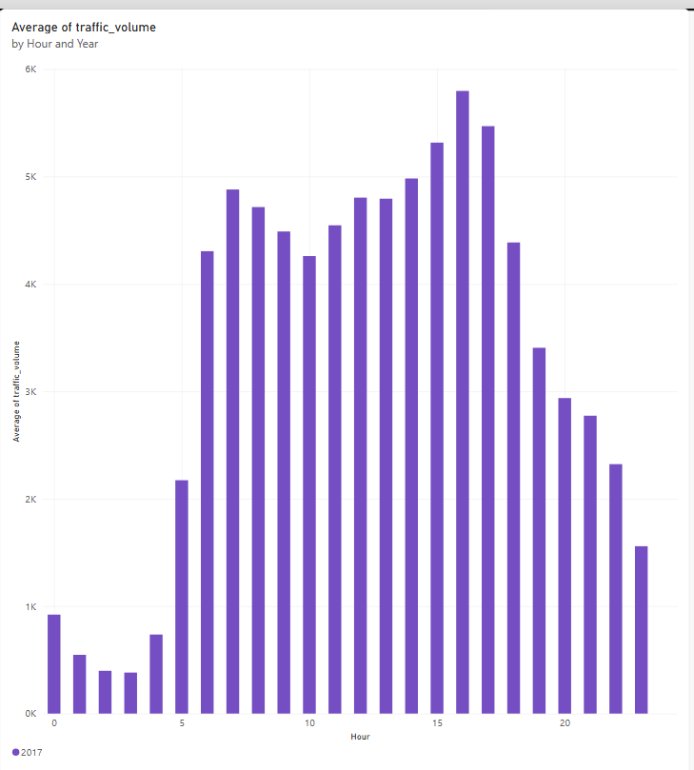
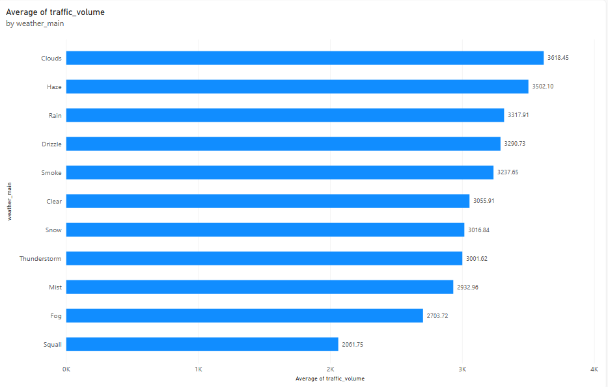
C. Weather impact
Clouds weather condition has the highest average traffic at 3618.45
Squall weather condition has the lowest average traffic at 2061.75
The difference between the highest and lowest average traffic is 1556.70

D. Temperature and traffic

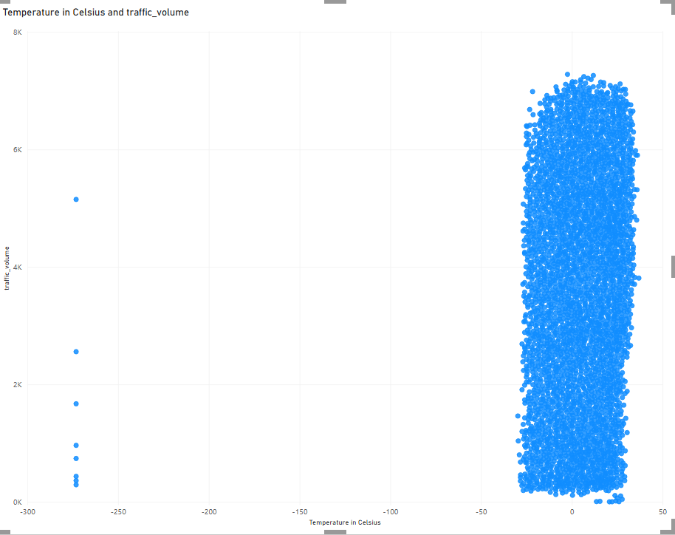
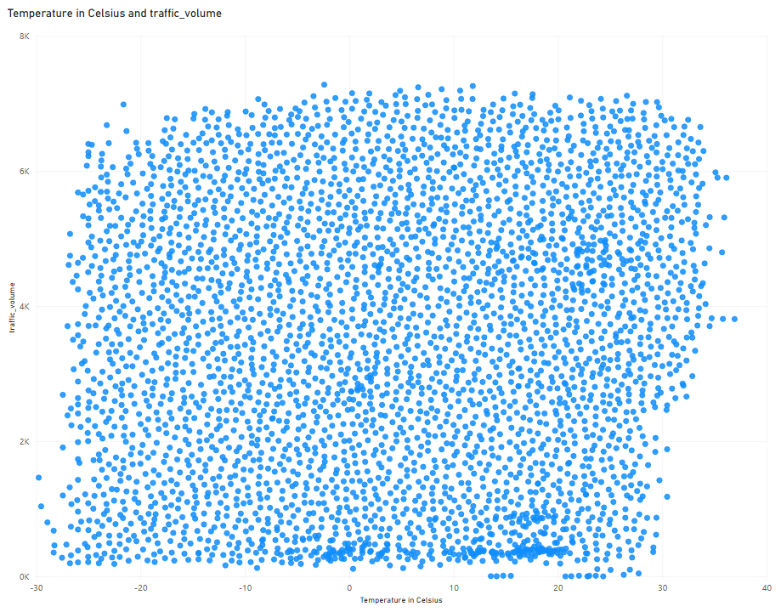
There is no visible linear relationship between temperature and traffic volume on the scatter plot. The data points do not form an upward or downward sloping line and instead form a highly dense, solid rectangular cloud in the chart. This also directly mirrors the weak Pearson Correlation coefficient of 0.1302 calculated earlier which proves that day-to-day temperature variations do not act as driving force for hourly traffic fluctuations. Traffic volume remains largely stable regardless of normal adjustments in weather temperature.
The highest traffic volume around 6000+ span incredibly wide, covering a temperature range from -15 deg C to 30 deg C. This proves the resilience of the commuters regardless of cold or warm weather.
The plot reveals a highly distinct vertical column of data points completely separated on the far left of the chart, resting at exactly -273.15 deg C. Because absolute zero is equal to -273.15 deg C, so these rows show up as extreme visual anomalies on the chart which are systemic data dropouts caused by malfunctioning highway telemetry sensors that logged a 0 value instead of a blank field.
